## References

* Real-time streaming in Power BI

<https://powerbi.microsoft.com/en-us/documentation/powerbi-service-real-time-streaming/#using-the-power-bi-rest-api>

* Event Hubs programming guide

<https://docs.microsoft.com/en-us/azure/Event-Hubs/event-hubs-programming-guide>

* Get started with Event Hubs and Receive messages with EventProcessorHost

<https://docs.microsoft.com/en-us/azure/event-hubs/event-hubs-csharp-ephcs-getstarted>

* Event Processor Host Best Practices

<https://blogs.msdn.microsoft.com/servicebus/2015/01/16/event-processor-host-best-practices-part-1/>

* Getting Started with Azure IoT services: Event Processor Host

<https://www.linkedin.com/pulse/getting-started-azure-iot-services-event-processor-host-rob-tiffany>

## Requirements

* Finished the part 3 of HOL
* Power BI account
* Simulator: **CSharpSimulator** & **RpiOnlineSimulatore**
* NuGet packages
  + Newtonsoft.Json for JSON in C# h9i0oplkl[;plpp][‘
  + .l
  + []\’];.]\4wpfl;m
  + Microsoft.Azure.ServiceBus.EventProcessorHost for Event Processor Host

## Goals

* Use the **Event Processor Host** to push the telemetry data to Power BI.
* Show the real-time dashboard in the Power BI portal.

## Step 1: Create Power BI Streaming dataset

* Sign in Power BI web portal (<https://powerbi.microsoft.com>)
* Click **create** and **streaming dataset.**

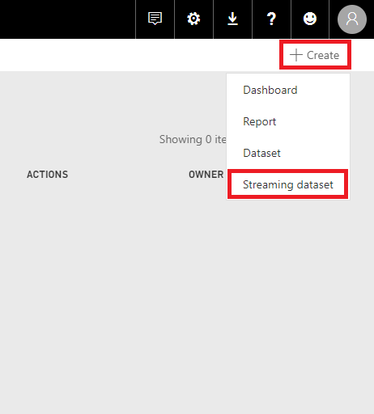

* Click **API** and **Next**

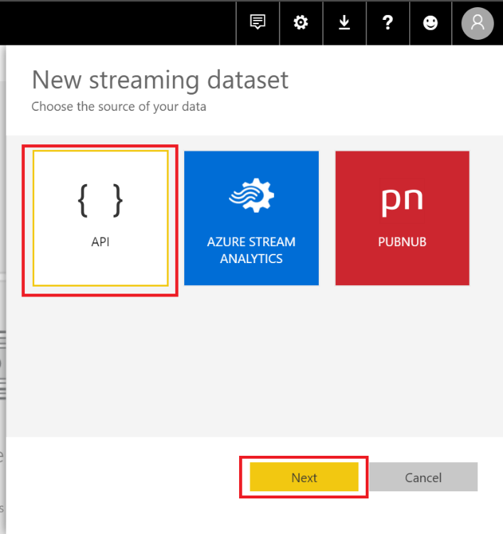

* Fill in the column Dataset name and fill out the format of data stream as below:

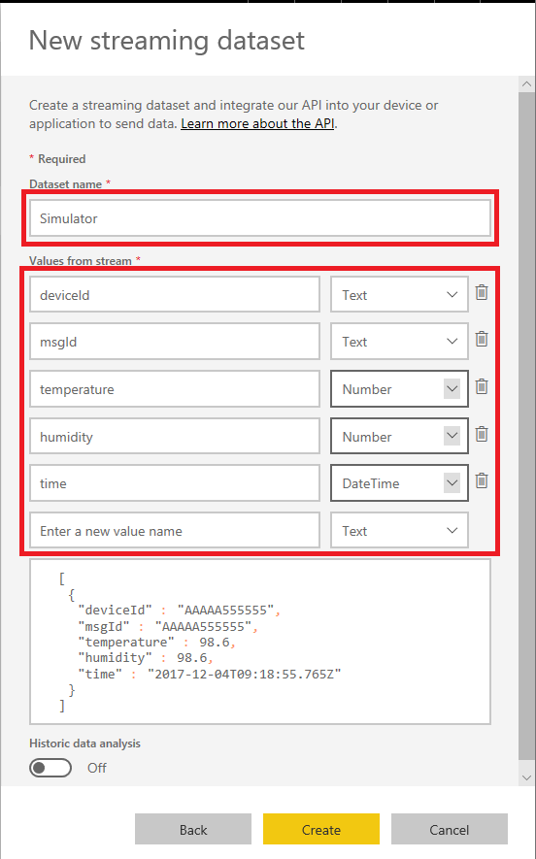**Dataset name:** *Simulator*

**Values from streaming data:**

|  |  |
| --- | --- |
| Column Name | Value Type |
| deviceId | Text |
| msgId | Text |
| temperature | Number |
| humidity | Number |
| time | DateTime |

* Copy Push URL into your note and click done

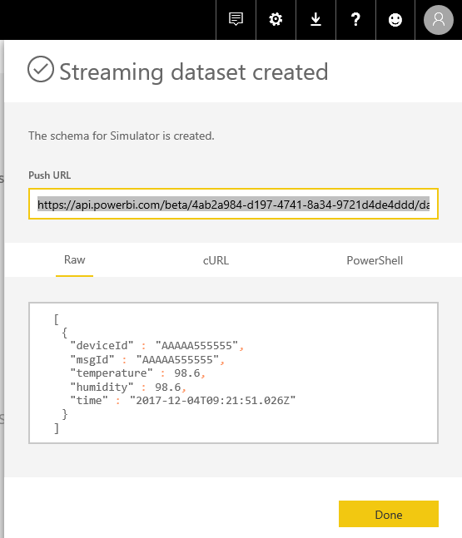

* There is a new dataset **Simulator** in your account

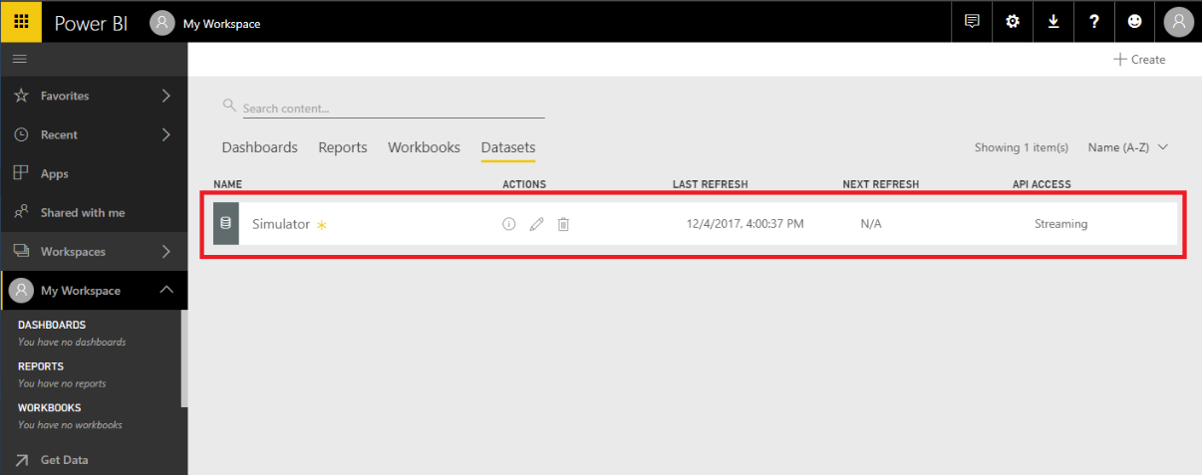

## Step 2: Make a Power BI real-time dashboard

* Click Create and Dashboard

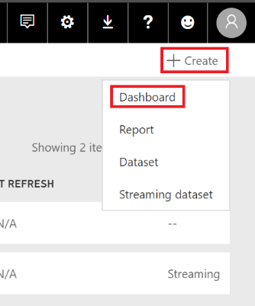

* In the **Create dashboard** dialog window, fill in the **Dashboard name:** *Simulator Analysis*

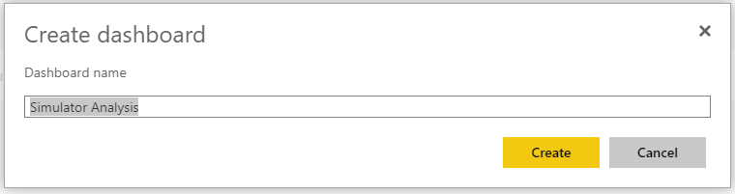

* Add new tile: Click **Add tile**, select **Custom Streaming Data** then click **Next**

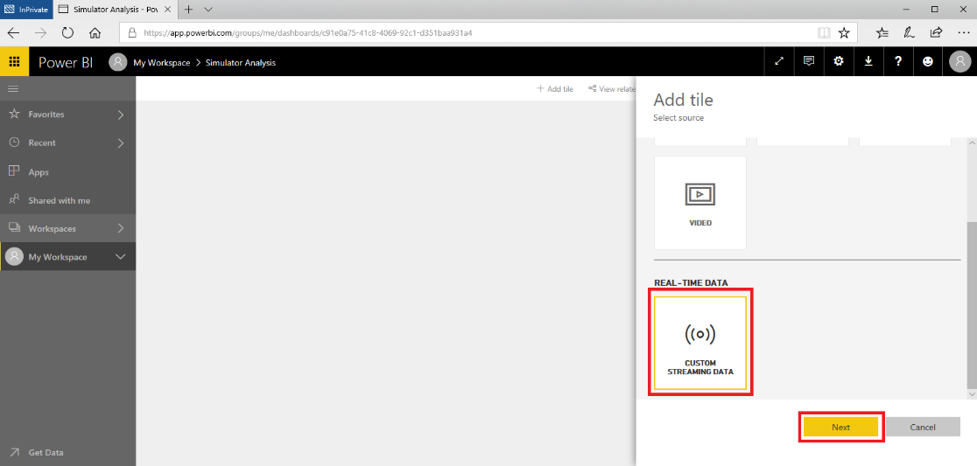

* Select streaming dataset you create before and click **Next**

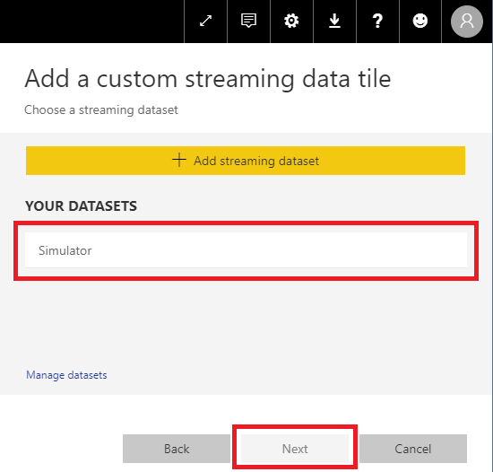

* Fill in the tile’s columns (Line chart, time, deviceId and temperature) as below image on the left and click **Next** button**,** then fill in the column **Title:** *Temperature*. Finally, click the **Apply** button.

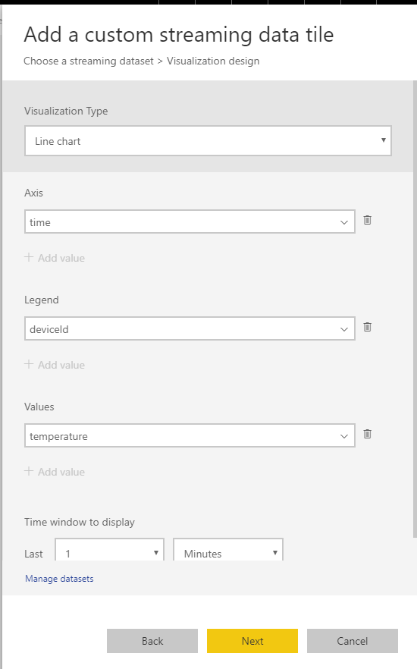 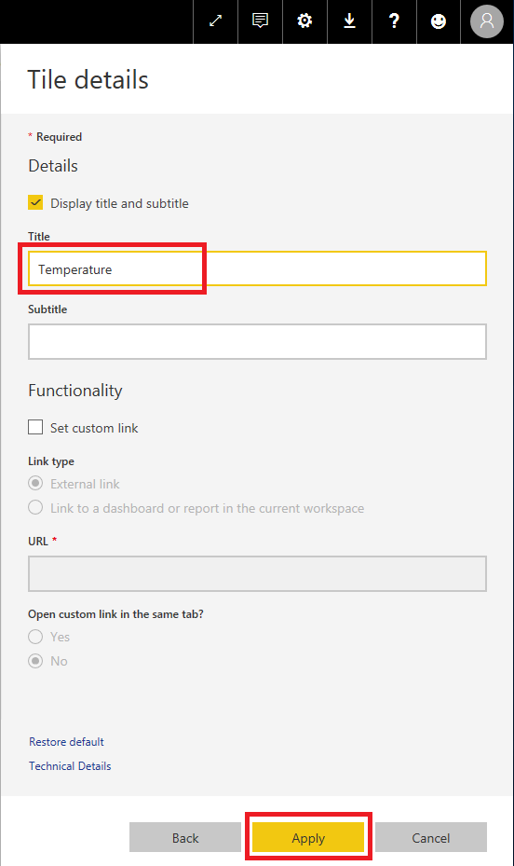

* A **Temperature** tile has been created and resize it as below

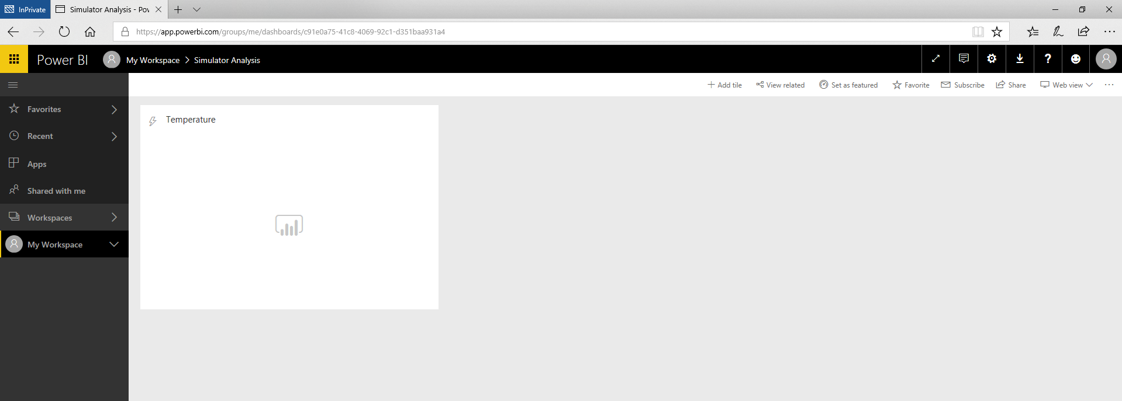

* Repeat above steps to create **Humidity** tile, Click **Add tile**, select **Custom Streaming Data** then click **Next**



* Select streaming dataset you create before and click **Next**



* 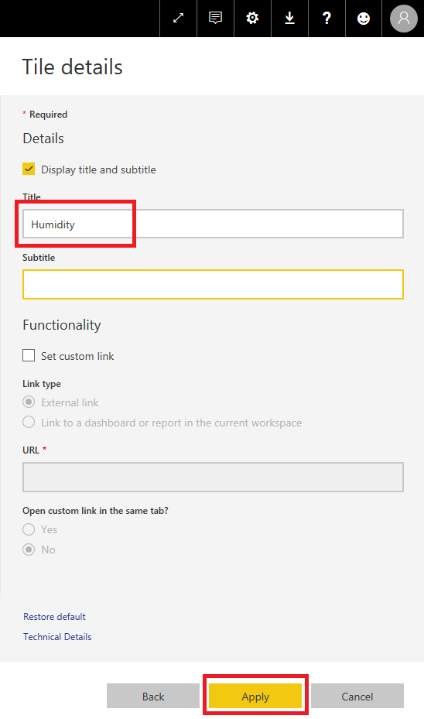Fill in the tile’s column as below image on the left and click **Next** button**,** then fill in the column **Title:** *Humidity*. Finally, click the **Apply** button.

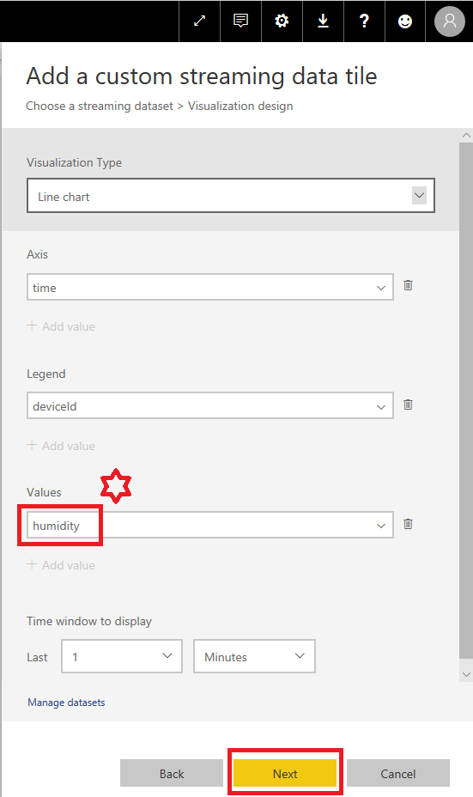

* A **Humidity** tile has been created and resize it as below

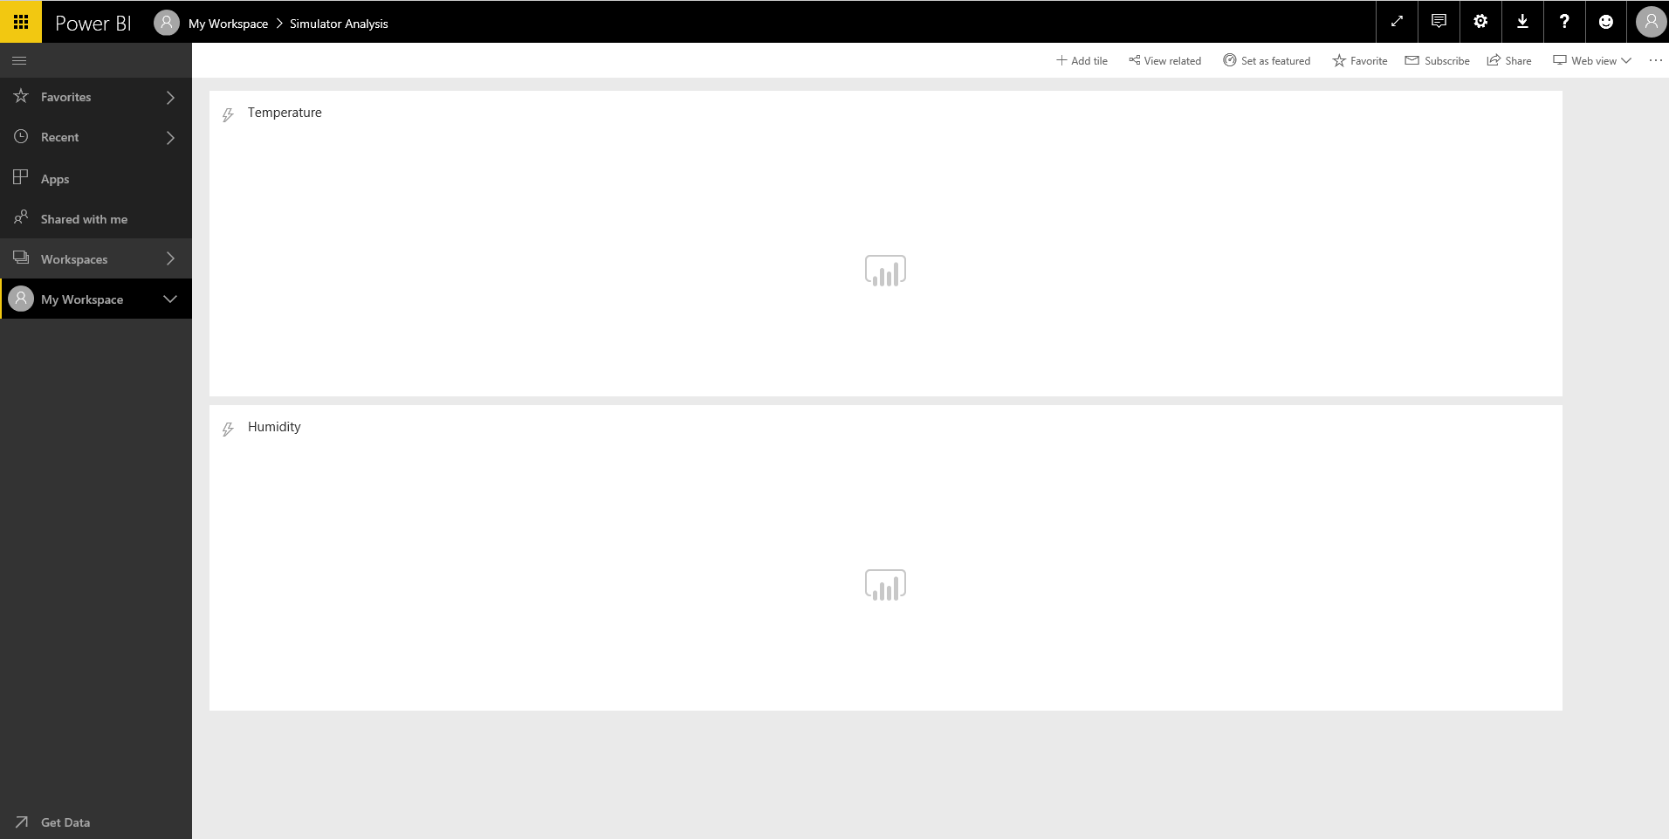

## Step 3: Build the Event Processor Host to push the telemetry data

* Confirm that you have created another Consumer groups of IoT Hub for Event Processor Host as **telemetrypush**.

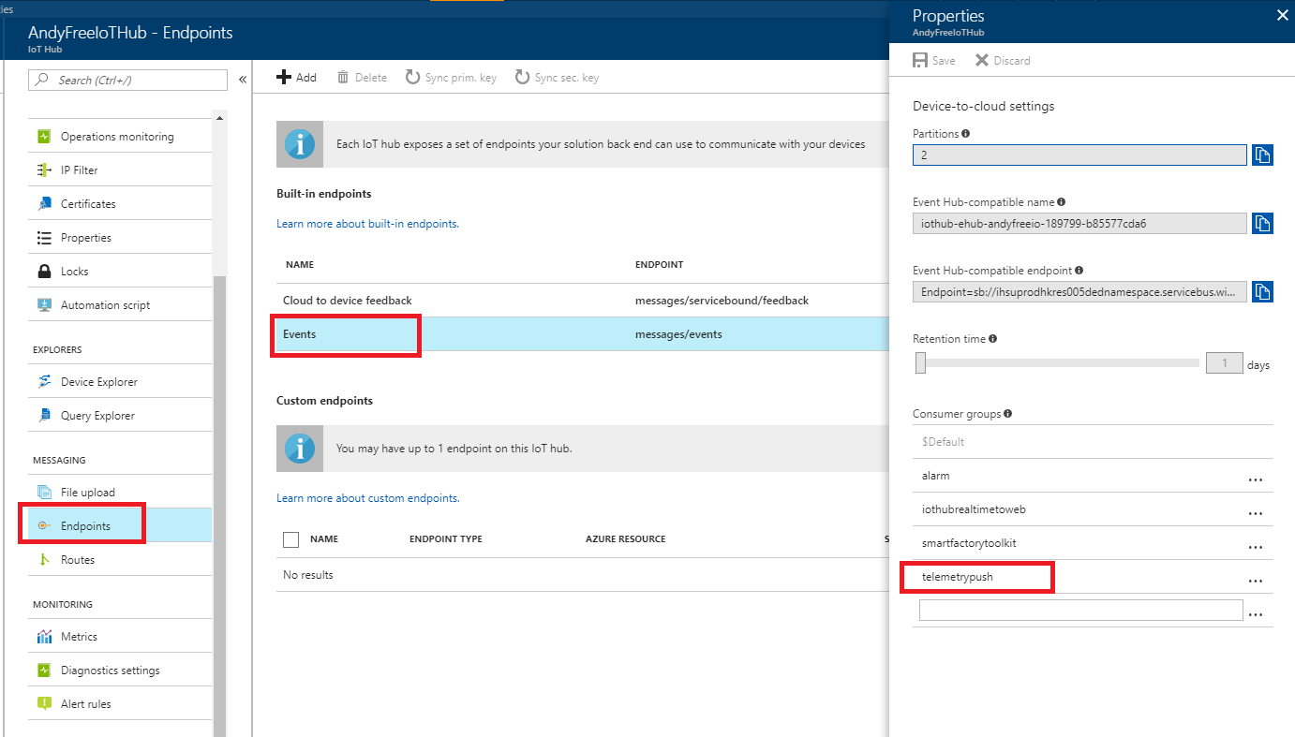

* Unzip the **TelemetryProcessor.zip** and open the solution in VS.
* Open the **App.config**. The definition of the configuration in the appSettings as the following.
  + **WebServer.isProduction**: 0 means it will be connected to local host; 1 means it will be connected to online web.
  + **WebServer.Localhost**: the url of local host.
  + **WebServer.Production**: the url of online website.
  + **PowerBI.API** : the url of Power BI push dataset
  + **IoTHub.ConnectionString**: the connection string of IoT Hub
  + **StorageAccount.ConnectionString**: the connection string of Storage Account
* Fill in the correct value
  + PowerBI.API
  + IoTHub.ConnectionString
  + StorageAccount.ConnectionString

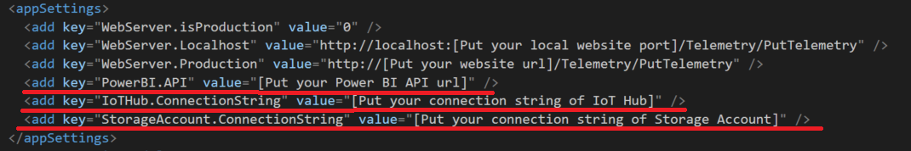

* Open **TelemetryEventProcessor.cs** and uncommand the line in the red box as below:

_webSC.PostTelemetryMessageToPowerBIAsync(data);

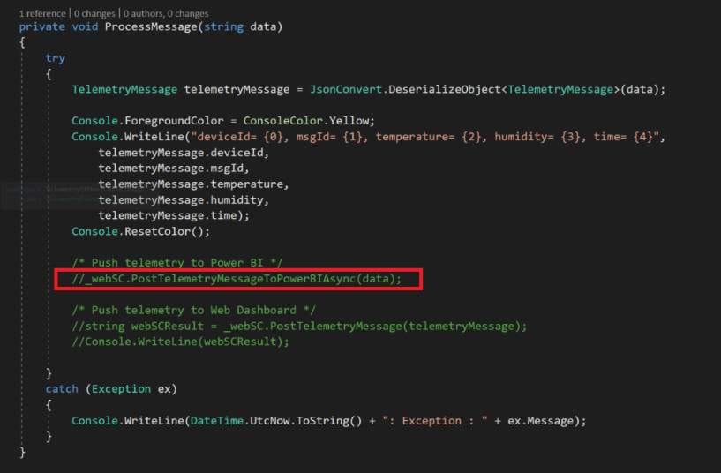

* Press F5 to run the Event Processor Host, also started the **CSharpSimulator** and **RpiOnlineSimulator**, then check the output of console App and Power BI dashboard as below.

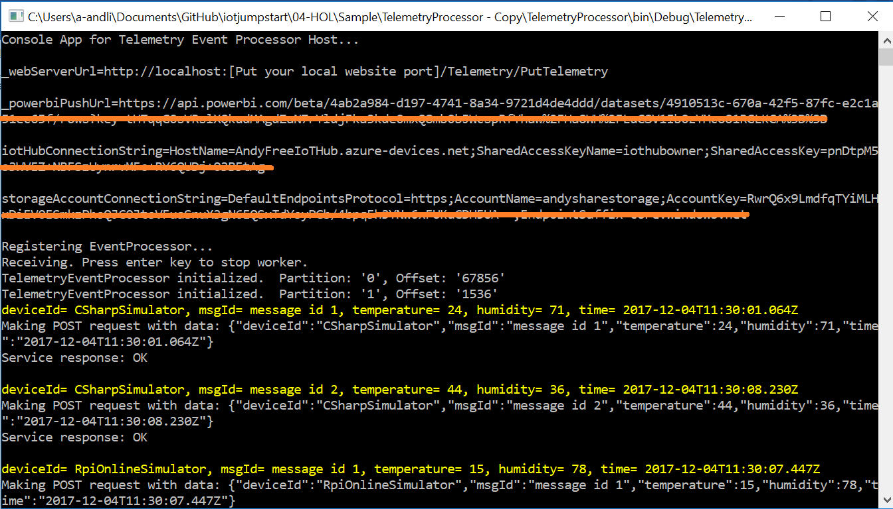

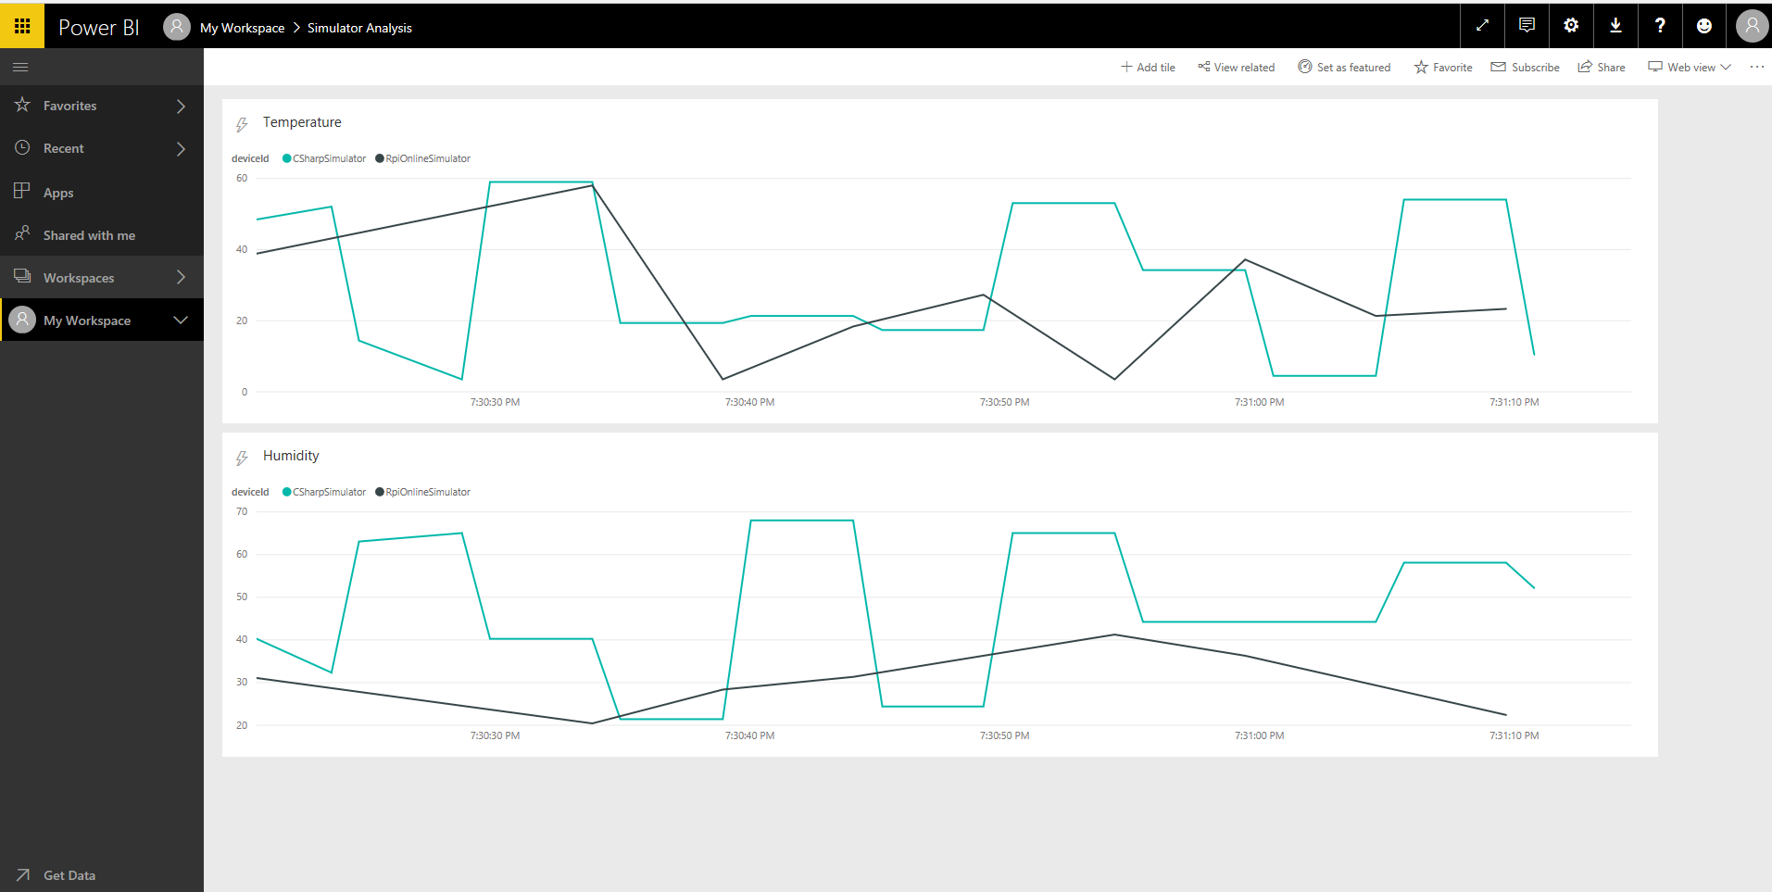

* *The HOL 4 has been completed. Now we can read the telemetry data from IoT Hub through the Event Processor Host, and feed-in the data to the Power BI push dataset by Http API. Finally, we can see the real-time dashboard in Power BI portal.*